Europa Mono Wheel Cowl Flap
Adding a movable cowl flap to a Europa mono wheel is a fairly easy task. I copied the basic design of Erich Trombley. The benefits are better control of oil and coolant temps, and airspeed increase of a few knots.
I fabricated the flap from .032 aluminum using this drawing.
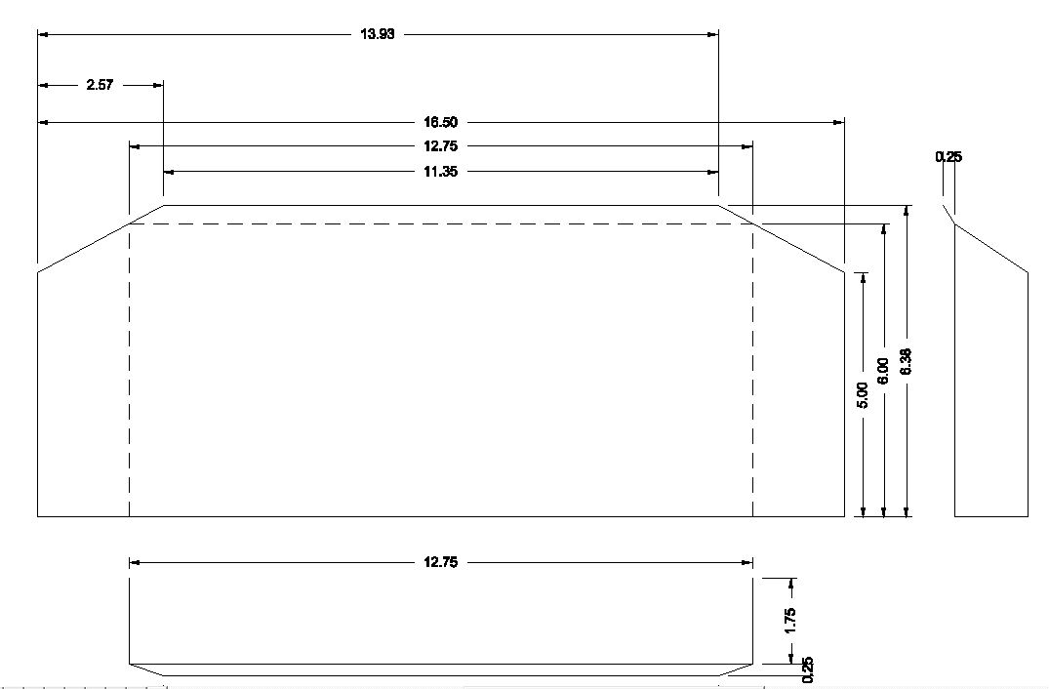
The flap is attached to the bottom of the oil cooler using MS20001-5 hinge.
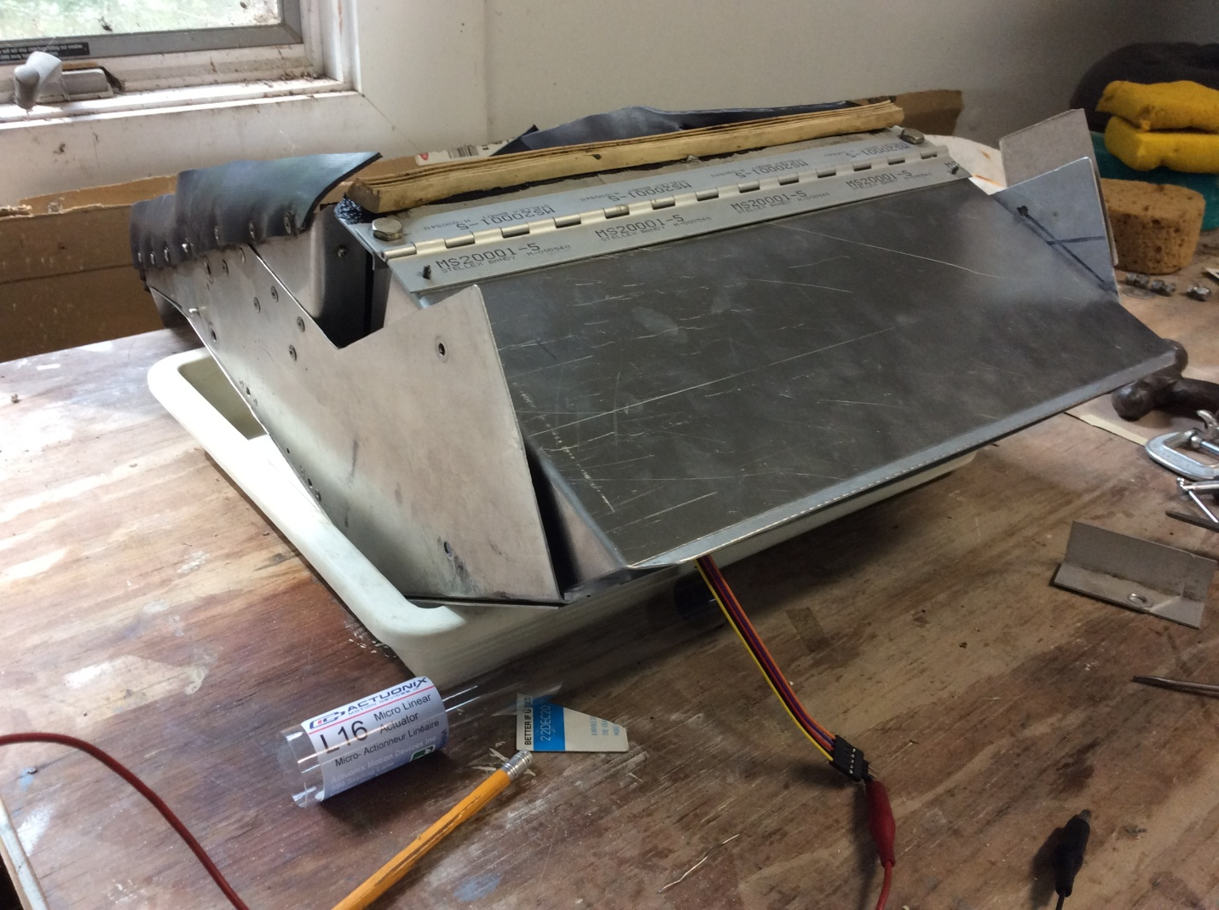

The linear actuator used is from Actuonix (Actuonix.com). At least one after market cowl flap kit for RV10s uses the same actuator. Originally, I used a L16-50-150-12-P. I have now changed to a P16-50-256-12-P because the air force on the flap would overpower the L16 actuator.
The actuators are available with built in limit switches (last field in part number is S not P) or with a built in potentiometer to transmit position (last field in part number is P not S). Erich and I use the P model so that we can display cowl flap position on our EFIS. In my case, using a GRT EIS/EFIS, the display lags the actual position a few seconds, so I pulse the actuator and see where it stops. Actual position is not critical, usually either full open or full closed. Full open is the cowl flap roughly in line with the bottom of the cowl. Full closed is about 1” of opening. Without limit switches for protection, it is easy to overextend the actuator and destroy it. That’s another reason for pulsing it and limiting the travel. If you choose to display position in the cockpit, order the extension cable to get enough length. The supplied connectors work well. If you use the limit switch model, then you have to devise a way to know when you are at the desired position. Probably powering it for short, uniform amounts of time (one thousand one, one thousand two etc) would work OK.
I found air pressure on the flap would cause the actuator to move when using the L16 actuator. To prevent this, I shorted the actuator inputs together when not powered. This required a special switch, a 2-70 using Aero Electric nomenclature. The actual switch is a Honeywell 32NT91-70. I’m using this same setup with the P16 actuator.
Here’s the completed installation
