Operator’s Manual – Kolb Mark III
Builder: Steven Green - 2001
N58SG

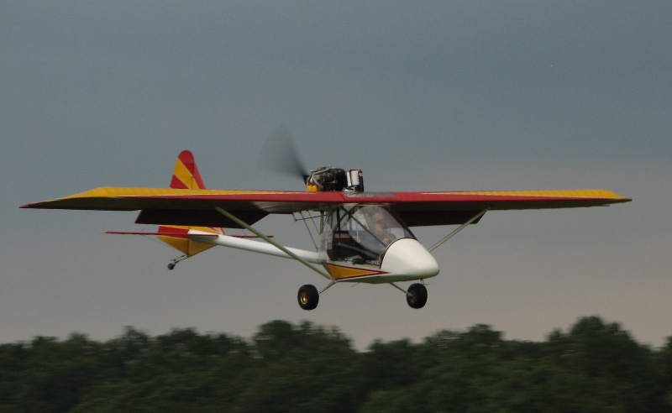

Contents

Setup and preparation
Before Starting Checklist
Before Takeoff Checklist
Takeoff
Cruise Checklist
Before Landing Checklist
Landing
Shutdown Checklist
Limitations
Emergency Operations

Setup:
See instructions

Preflight Inspection Checklist:
See laminated checklist

Starting Checklist:
Fuel level: Check
Starting Circuit Fuse: Insert, if removed for safety between flights
Document data
EIS Hours
Hobbs Hours
Fuel level
Accessories: Off
Brakes: Held
Master Switch: On
Electric Fuel Pump: on for 10 seconds
Mags: Both on
Area: Clear
Choke: On
Throttle: Closed
Starter: Engage (10 second maximum, x 2, followed by 2 minute cool-down)
When started: Slowly release choke/ advance throttle to 1500rpm
Oil Pressure: Check
Accessories: On
Intercom: On
Headset volume: Full
Radio and GPS: On
Strobes: On
ATIS: Record
Altimeter: Set
BRS Pin: Remove

Before Takeoff Checklist:
ATIS: Confirm
Runway number: Confirm
Controls: Free and correct
Trim: Set for takeoff
Headset volume-full
Brake: Held
Throttle: 3200rpm
Mags: Check individually – Maximum drop=100rpm / Difference=50rpm
Throttle: 1600rpm
Oil Temp: Minimum 120 Degrees Fahrenheit
Fuel level: Check
BRS Pin: Check removed

Takeoff:
Clearance for takeoff: Read back
Align with runway
Apply back pressure
Advance throttle smoothly to “Full”
Back pressure: Slowly relax to raise tail
Rotate at 40 kts.
Establish and maintain safe climb airspeed
Vx – 45kts.
Vy – 55kts.

Cruise Checklist:
Attitude: Level
Throttle:
5500rpm max
4800rpm economy
4100rpm pattern
Trim: Adjust for neutral elevator pressure

Before Landing Checklist:
Check ATIS
Clearance for landing: Read back
Throttle: 4100rpm
Trim: None
Pattern airspeed: 50kts. - Minimum
Approach airspeed: 50kts. – Minimum
Flaps: As needed

Landing:
Approach Airspeed: 50kts. – Minimum
Flare: 1 to 2 feet
Rollout: Maintain runway alignment
Brakes: As needed

Shutdown Checklist:
Strobes: Off
Radio and GPS: Off
Intercom: Off
Accessories: Off
Mags: Off
Master: Off
BRS Pin: Insert
Starting Circuit Fuse: Remove for safety

Emergency Checklists:
Power loss on takeoff:
Trim and Maintain safe airspeed - 50 kts.
Below 1000 feet- Maintain heading w/in 45 degrees
Above 1000 feet- Gentle turns toward suitable field
Mags- Check Both On
Flaps: Apply as needed once field is made
Communicate: Mayday, location, nature of emergency if time permits
Landing Airspeed: Minimum 50kts.

Power loss in cruise:
Trim and maintain safe airspeed 40-50 kts.

Suitable Field Available:
Select and steer for suitable field
Mags: Check Both On
See ‘Power loss on takeoff’

Suitable field unavailable:
Trim and maintain safe airspeed
At Safe Altitude, (500ft. minimum,) slow to 40kts.
Mags: Off
BRS: Deploy

Limitations:
Stall speeds (IAS) -
Vs0 – 25kts.
Vs1 – 30kts.
Best Glide – 40-50kts.
Vx – 45kts.
Vy – 50kts.
Mfe – 55kts.
Va – 70kts.
Vne – 80kts.

Horsepower: | 100 hp
Fuel Capacity: | 20 gal
Cruise: | 70 kts
Stall: | 30 kts (Vs1)
Climb: | 1,100 ft/min
Takeoff Distance: | 175 ft
Landing Distance: | 250 ft

Kolb Mark III Specifications
Gross Weight: | 1,050 lbs
Empty Weight: | 591 lbs
Useful Load: | 459 lbs
Wingspan: | 30 ft
Length: | 24 ft
Height: | 6.33 ft

