WEIGHT AND BALANCE REPORT
Aero Vodochody L-29 N8164C S/N093734

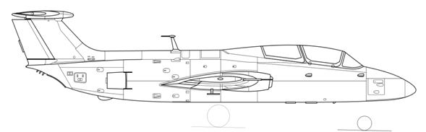
B
256.26
114.45
80.31
7.28
38.98
169.29
11
Name
Empty Plane | E
Fuel Main Tanks | M
Pilot Front Cockpit | P1
Pilot Rear Cockpit | P2
Aux Fuel Tanks | A
15% Minimum Fuel – 150l | Mm
Ballast | B
20.1
25%
163.58
P2
133.62
M
E
A
Mm
80
MAC
P1
Name | Weight | Arm | Moment | CG Aft of Datum | %MAC
Main Gear | 4850 | 31.72 | 153842
Nose Gear | 240 | -90.58 | -21739
Ballast | 65 | -163.58 | -10633
Empty Weight | 5155 |  | 121470 | 23.56
Pilot Front Cockpit | 198 | -83.58 | -16549
Pilot Rear Cockpit | 198/0 | -29.96 | -5932/0
Fuel Main Tanks 39.6/264gal*6.7 | 261/1769 | 22.72 | 5930/40192
Aux Fuel Tanks 79gal*6.7 | 0/529 | 20.28 | 0/10728
 | 5812/7651 |  | 104919/155841 | 18.05/20.37 | 22.48/25.36
Aircraft weight with parachutes installed and gear extended – Retracting the gear moves CG forward 0.7 - 1.1%
All weights are in pounds and all dimensions are in inches. Fuel weight 6.7lb/gal.

Approved CG Range 20.5% - 25.5% MAC (16.46” – 20.47” Aft of Datum)
Most Forward CG - 2 Pilots, Min Fuel / Most Aft CG – 1 Pilot, Full Fuel

______________________________

0
191.02
187.05
186.29
179.92

