Europa Cowl Landing Light

The following diagrams and text provide details of the mounting location and method for a powerful landing light fitted in the belly of the Europa cowl.
The power for the light is provided from the master switch bus bar via a switch accessible by the pilot from the cockpit and a suitable circuit breaker. The switch should be the type that illuminates when the power is switch through to the light. The SL3919 Tech Light draws only 2.4 amps.
The routing of the power cable should be chosen such that it is away from any strong heat source, e.g. the exhaust pipes.
The cable provided with the light is rated for automobile installations and is fitted with an IP68 waterproof connector. The connector needs to be accessible so it can be connected/disconnected whilst the cowl is either still fitted, or where it has been lowered, but not yet removed fully.
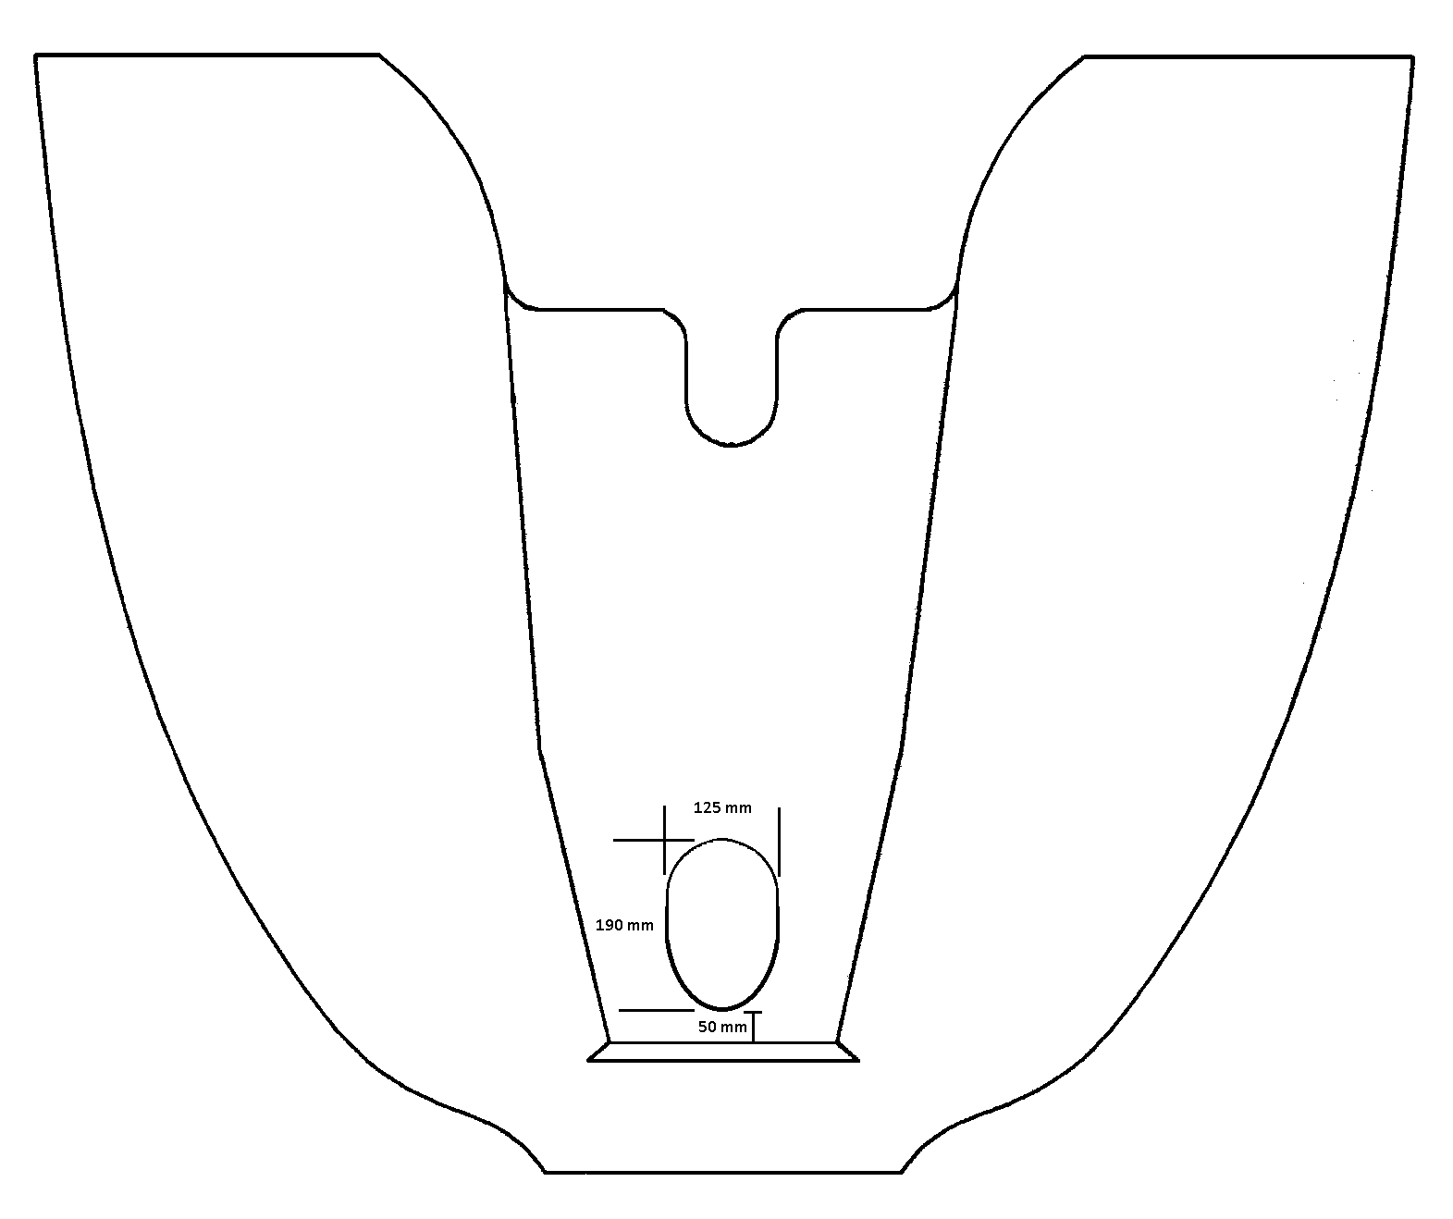
A view looking at the bottom of the cowl and showing the location and dimensions of the hole required for the light. The hole is elongated towards the front of the cowl to provide an unobstructed path for the light beam.

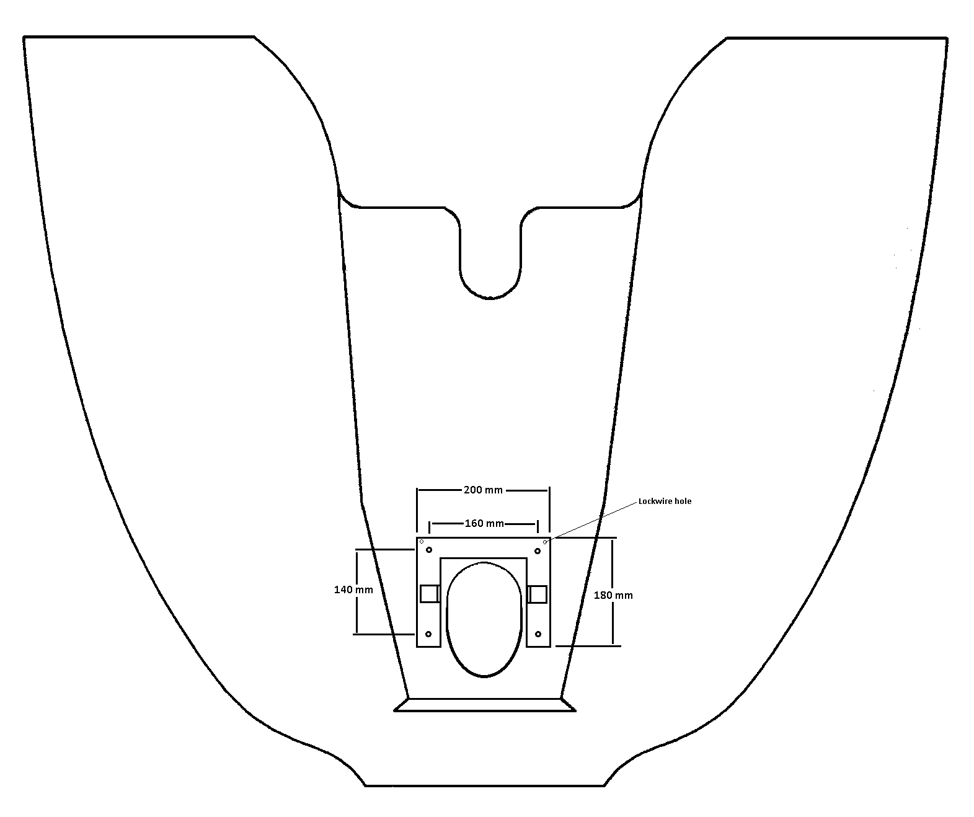
A view looking down inside the cowl showing the location of the mounting bracket. The bracket made from 1.5 mm aluminium sheet and is bent slightly to follow the profile of the interior of the cowl over which it sits. The bracket is secured by four domed, hex-head screws that pass through the belly of the cowl and into anchor nuts, each attached to the inside face of the bracket by two rivets.
The light is secured to two right-angled brackets made of 1.5 mm aluminium sheet via two of the mounting bolts supplied with the light. Loctite thread lock fluid is applied to the bolts to prevent them coming loose.
The right-angled brackets are secured to the main bracket using 2 mm pop-rivets.
Lock-wire is used to provide additional security by passing it through the redundant rear mounting hole on each side of the light and through holes in the main bracket.

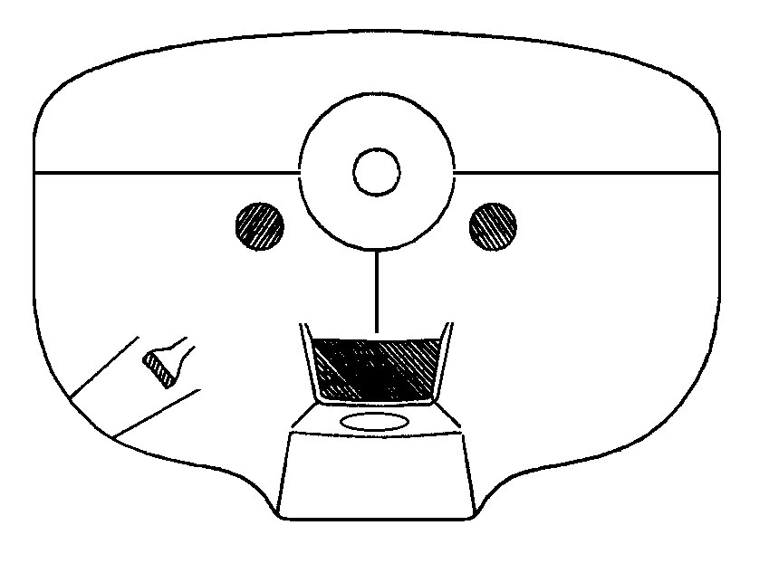
View of the opening from the front.
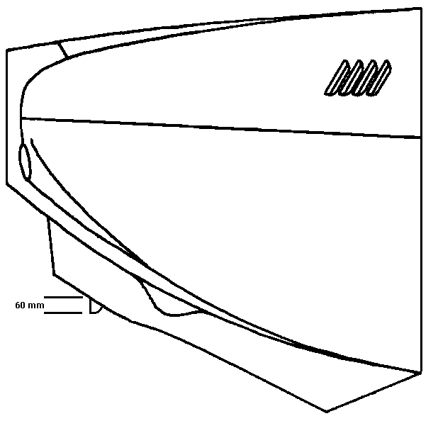
View from the side. The light protrudes below the cowl belly by half its diameter. Consequently the light protrudes inside the mouth of the cowl by half its diameter. However, as the light has cooling fins that align laterally with the body of the aircraft, there is little obstruction of the air flow to the oil and water radiators. The airflow through the fins dissipate any heat coming from body of the light.

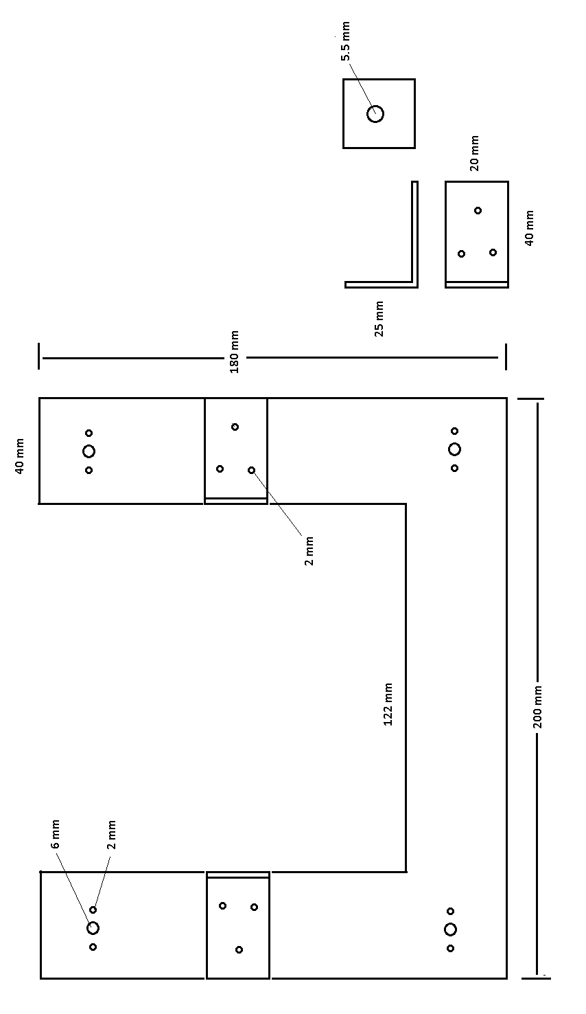
All bracket parts made from 1.5 mm aluminium sheet.

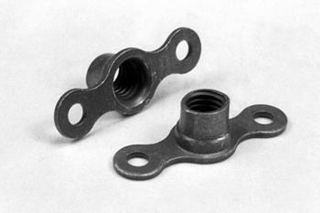 Two lug anchor nuts - MS21047-3
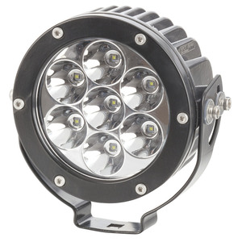S3919 Tech Light. 3846 Lumen IP68 Solid LED Spotlight
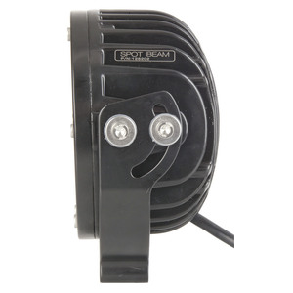The mounting bracket provided is not required, however the mounting bolts and washers are used to secure the light to the bracket. The rear bolt hole is used as a point to attach lock-wire.
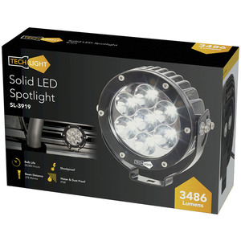The light is shock proof and has a 50,000 hour lifespan.

