Fitting a Dynon Heated AOA Pitot Probe

The following diagrams and text provide details of the mounting location and method of a Dynon Heated AOA Pitot probe to the underside of the Europa’s port wing. The design replaces the exiting pitot tube and uses the same mounting location and attachment method with the addition of joggle bonded to the wings surface to retain the rear if the larger Dynon mounting post.
As the Dynon probe’s temperature is regulated rather than being constantly heated, it requires a control unit. This will be mounted to the inside if the root rib of the port wing in the gap between the wing and the fuselage.
Power to the probe from the regulator will be carried over three 14 SWG wires routed down the tunnel provided for the aileron torque tube. In addition, two further 22 SWG wires will be routed alongside the power wiring, and then on to the SkyView EFIS where they will terminate on suitably configured monitor connections. This will raise an alert on the EFIS if the probe is not functioning correctly. As the wiring occupies little space it will provide no restriction to the movement of the torque tube.
Power to the regulator will be carried over 14 SWG wires from the master switch bus bar via 10 Amp circuit breaker located on the central console panel. As the regulator is designed to be constantly powered there is no requirement for a switch. Should it be necessary to remove power from the pitot, the circuit breaker will be activated.
The existing pitot tubing will be connected to dynamic and angle-of-attack (AOA) tubes within the mounting post. As the aircraft is not pressurised, the intention is to provide static sources for the existing EFIS and back-up instruments from tubing that is left open within the central tunnel of the aircraft. Testing will be carried out to see if this allows the airspeed to be reported accurately. If not, static ports will be provided in the fuselage.

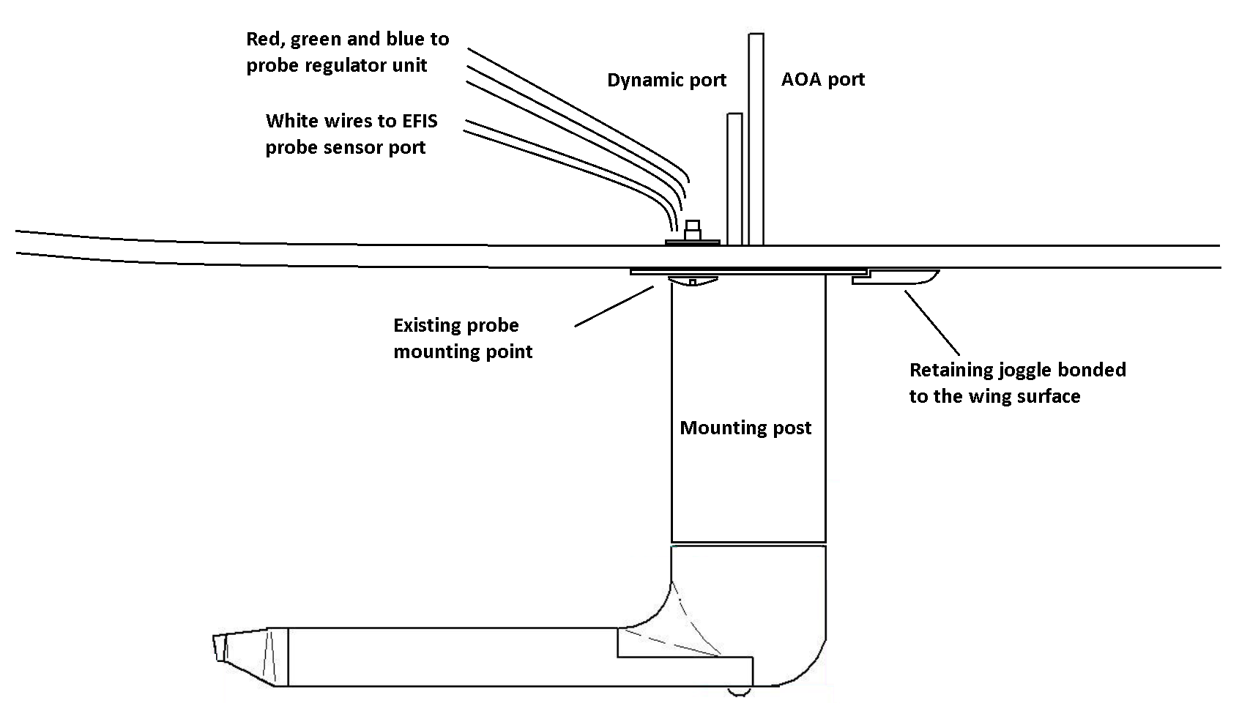

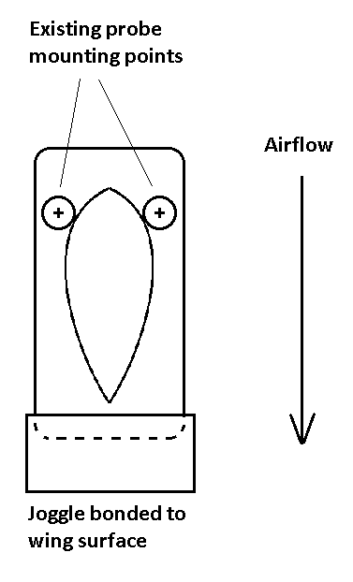

Gretz Aero Paintable Pitot Mounting Post
