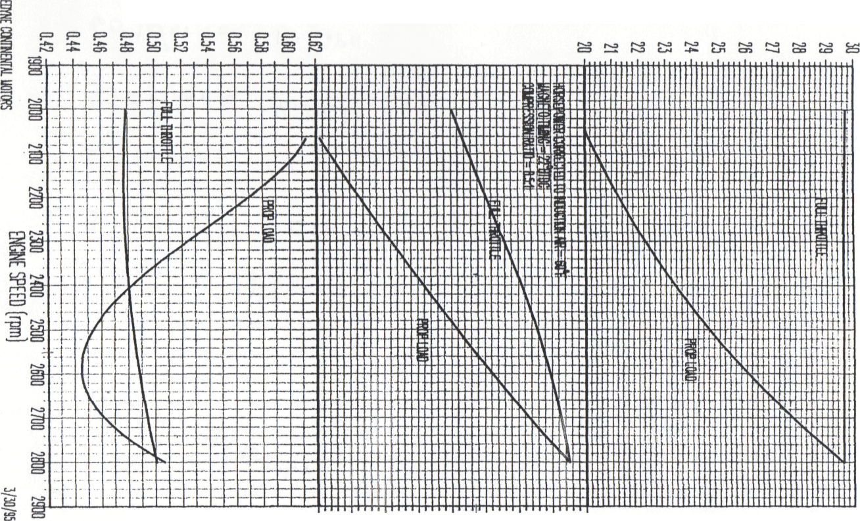

N> M
BSFC (Ibs/hr/BHPo)
£3 S ^ § £§
CORRECTED BRAKE [JORSEPOWER
F3
&^

tr\
ABSOLUTE DRY MANIFOLD PRESSURE (in. Hg)
cn
=1
oor
o
O I
fcd
S O cl
0)
on
13 (t> O H-Iti H-
n to rt
H-O
3

