The Task at Hand
Rotax 5 Year Rubber Replacement
Part 1

This discussion is going to focus on a topic that will undoubtedly have Rotax engine owners on both sides of the fence, both for and against in a major discussion, but I hope to instill a sense of “Doing things right and for the right reason” and without all the worry some seem to have over this solid and sound maintenance practice. As you can see from the last few words in the last sentence this article will focus on the positives and good maintenance practice and hopefully get away from the all encompassing “Don’t fix it if it isn’t broke” concept. I do believe that some items are fine to be on a condition inspection or even wait until it wears out, but those are not flight safety issues or will they present a hazard when they fail. Planes in general and the hose change cost money , I’ll be the first to admit that, but you decided to fly and now you need to ask yourself what your life and your passenger’s life is worth and do you want to spend a little money now and keep safe and flying or spend a lot later and be grounded?
The Rotax Line Maintenance manual dated 09-20-12, Section 05-10-00, paragraph 2.1 and subject head “Time limit for rubber parts” is the section we will be addressing in this article. There are two important issues here to cover. First is the issue with hose time limits and how long will a rubber hose last? The second and possibly more important is hose selection and the right way to install a hose which is covered in part 2 of this article.
Many of the machines we use now days in a high risk environment have some type of maintenance program the manufacturer wants followed and some are mandatory. Even our automobiles have a recommended hose, serpentine belts and V-belt replacement program. Some owners are good about following these practices and of course we see some autos stranded on the side of the road or even a damaged plane in an off field landing and these folks may not have been as good about their maintenance practices. Even with a good maintenance program mechanical parts and hose can and do fail. The whole idea is to put the odds in our favor and not test the limits. If we are in our auto and have a hose failure we can pull over and call for assistance. If we are flying in our aircraft then a hose failure is probably going to bring you and possibly a loved one down in the worst possible area. Do aircraft hoses fail before their time? Yes they do and have caused many an aircraft emergency. With that in mind many aircraft engine and aircraft manufactures in general have recommended time tables to which they recommend a hose maintenance program which is usually backed up by 20-60 years worth of data and failures not to mention the recommendation right from the hose manufacturer themselves. The bottom line is Rotax and others are trying to error on the side of safety and not test the limits of each hose within the hostile environment in the engine compartment as you are flying over the Grand Canyon. If you are one that says don’t fix it until it breaks then you may be willing to switch sides as you glide down into the Grand Canyon that has no landing areas and a has the fast running Colorado river.
Many aircraft manufacturers now recommend that you follow the Rotax 5 year rubber replacement program. So how long is oil, fuel and coolant hose good for? The answer is, who knows for sure. Could it last only one year before a failure, yes. Could it last ten years before a failure, yes. No one can ever tell you exactly when a hose may fail so we use decades of observance and factor in some safety and make our best guess for you to get to that point and not have an issue. Over the last several years we are seeing a huge increase in owner compliance with the hose replacement program and that’s good news, but too many have had hose particles reaching the carbs and causing a power reduction.
The immediate response has been that it must be bad hose, but in 98% of the cases it has been mechanical damage from poor installation practices and possibly poor hose choices. There have been a few pieces of bad hose and Rotax issued a Service Bulletin for the fuel pump hose because of that very issue, but that is usually very rare compared to the amount of hose actually sold and used. Let’s look at the hose time table for replacement. Many want it to be a condition inspection replacement item. Okay so what are your replacement limits? Is it when the hose gets hard? That’s too late in the game. What about the fuel and oil hose in the fire sleeve? Do you dismantle all that hose and pull it all out of the fire sleeve to inspect it? I know of no one that does that. While you are looking at the outside what about the inside that begins to flake or degrade from time? How do you inspect that? How do you inspect the hose for cracking and separation under the hose clamp at the edge of the fitting on the inside and outside of the hose? (This is the most common problem area.) How many of you have been trained by a hose manufacturer to know even what to look for or were you just taking someone else’s word for your education?
So looking at it from a safety stand point, none of us are hose experts or have all the data the engine and hose manufacturer have so it just makes good common sense to error on the safe and practical side for you and your passenger’s safety. I would like to mention one other item here and look at it from a legal burden which none of us hopes to have to encounter. If you have someone in the plane with you and go down because of a hose failure and it is past the aircraft and engine manufacturers recommend rubber replacement time and the other person or other person’s family member takes you to court I would hope that you can back up all the good solid reasons that you didn’t do the recommended maintenance because it will be brought up and your hose expertise will come to the forefront. Family members and their lawyers are not very forgiving. That alone is enough to scare me because I have been to those types of court cases for over 30 years. If you error on the right and safe side it is much easier to defend from a legal standpoint.

Rotax 5 Year Rubber Replacement
The Installation Considerations
Part 2

For those who have decided that they will do a Rotax 5 year rubber replacement we need to look at what it covers and how we can utilize good sterile maintenance practices to keep debris from our hose lines. I will admit that there is more than one way to accomplish this procedure and what will be discussed in this article is, but one way.
The Rotax 5 year rubber replacement covers all fuel, oil and coolant lines. It covers any V-belt, carburetor diaphragm and carburetor rubber intake sockets and any other air intake rubber hose or tubing. With the new maintenance manual just out the fuel pump has been added as a replacement item too. So now you need to decide what brand hose you are going to use. Should it be fuel injection hose or standard carburetor hose? Since we are dealing with a worldwide distribution for engines the hose selection can be vast, but by all means should be thought out. We need to decide what tools we are going to use to cut the hose and how we are going to secure it in place. These again will vary depending on your geographical location.
Since I live in the US and have access to many a mechanic and can relate to my own observations I’ll use this as a base for my comments and you can adapt and or re-think how it may pertain to you where you live.
I have access to the Rotax hose change practices, information and results from several mechanics including myself which easily covers a couple hundred Rotax engine hose change procedures.
Rubber fuel hose was really not intended to push over barbed fittings as documented on several fuel hose manufacture websites. They prefer the flared or bulb end to slide the hose over. That said most of us have exactly that, barbed hose ends on many aircraft installations. What we have found is that fuel injection hose is less flexible than the standard carburetor hose. When you try to push fuel injection hose over a barbed fitting it has less give because of its pressure rating and tends to scrape the hose liner and small particles then float down stream. This is exacerbated by using a cutting tool with a serrated edge. Something like serrated edge scissors. Then add using the wrong style clamp and over tightening the clamp crushing the hose all adds to debris floating down stream towards your carburetors and a power loss when you absolutely don’t want one. So picking our hose type, tools and clamps are important ahead of time. As the old saying goes, “Failure to plan is planning to fail”.
Generally speaking, fuel injection hose has a working pressure normally around 100 psi and a burst pressure of around 900 psi. Standard carburetor fuel hose has a working pressure of 50 psi and a burst of 250 psi. The good thing with the standard carburetor hose is it has a little give in it since it isn’t as stiff and rated for the higher fuel injection pressure. This hose will slide over the flared, bulb or barbed fittings much easier and there is far less chance of scraping the inner liner and causing unwanted debris. A smooth inner liner is more preferable than a raised criss-cross pattern on the inside of some fuel injected hose which is caused by the thread re-enforcement of the hose. This tends to scrape more with a barbed fitting. I know everyone remembers that our normal 912 fuel system operating pressure is up to 2.2 to 5.8 psi for the 912UL or ULS engine. So let’s just say the upward limit is 6 psi to round it off. So using the standard carburetor hose works just fine with plenty a pressure safety margin.
Now who’s brand to use? Well that is up to you and where you live in the world. For me and many of my mechanic friends we have been using Gates Barricade Greenshield technology standard carburetor hose. It has 4 liners and is rated for any fuel and even 100% alcohol.
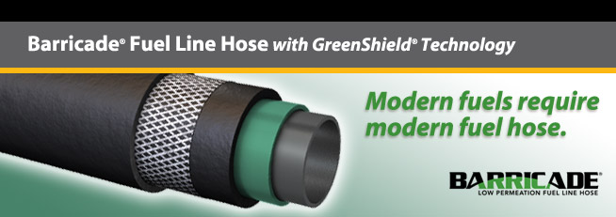

That should pretty much cover anything we will put in our 912 engine. We have not had any issues with scraping inside lining or hose degradation. The other big issue here is to use the proper cutting tool. I used to manufacture dive compressors and used 200’K of hose a year and needed perfectly smooth cuts. I use a Sears Craftsman Utility cutter Craftsman 3-7/8 in. Handi-Cut, item #00937301000, Mfr. model #37301.
http://www.sears.com/shc/s/p_10153_12605_00937301000P?mv=rr

It has a 3 7/8” long straight and scalpel sharp edge. It leaves a perfectly smooth cut and will handle any hose on a 912 engine. Serrated edge cutters will leave very tiny particles on a cut edge which gets shoved into the hose line when pushed over a fitting.
Hose clamps. I’m sure everything gets used here. You really should not use the standard hose clamp with the serrated openings like you buy in a hardware store. Yes they do get used, yes they have been around a long time, but they don’t give a good solid 360 degree seal, they can be over tightened and easily stripped and they cut into the outside of the hose. If you absolutely want to use a screw type clamp then use a fuel injection clamp. It doesn’t cut into the hose, you can’t strip it and it does a better job with a 360 degree seal. If you have to use a screw clamp then the one in the picture below with the raised ribs is a better choice and doesn’t over cam and strip and won’t cut into the hose. These clamps are better for coolant hose and not fuel. The next picture shows a fuel injection clamp (on the left) verses the standard hardware store clamp. Fuel injection clamps are good for oil hose and if you don’t have access to good Oetiker clamps then it’s a good second choice for fuel.
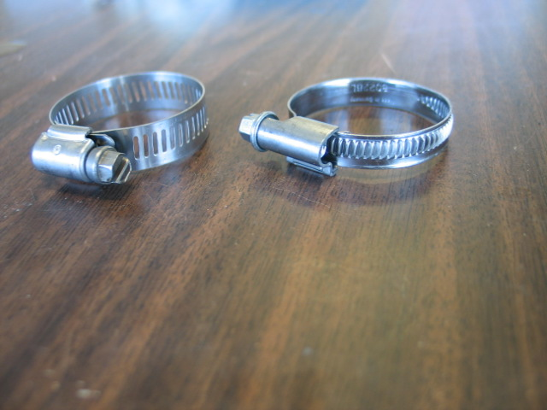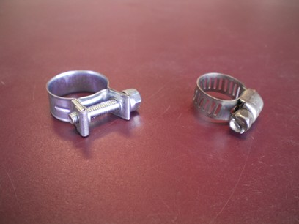
The better way to go and is preferable as an industry standard is something like an Oetiker band clamp. (Pictured below) I personally use a stainless steel one ear stepless Oetiker clamp on all fuel hose applications. They come in all sizes from the very tiny to the very large. It slides over the hose and you use a set of pinch pliers to squeeze it shut. I know then it won’t rust, it can’t come loose and provides an excellent 360 degree seal. One note for this clamp is to use the correct size and don’t use too small a clamp and crush it to death especially over a barbed fitting.
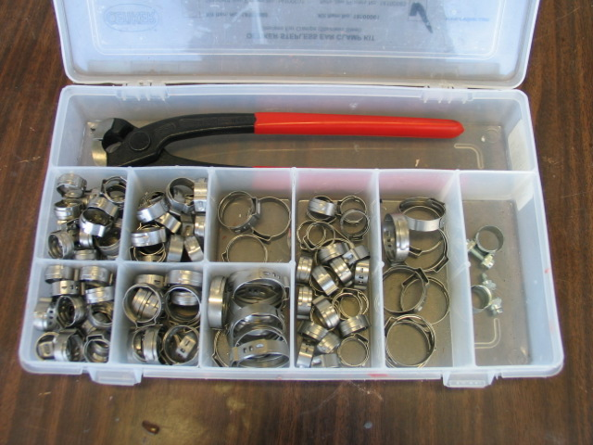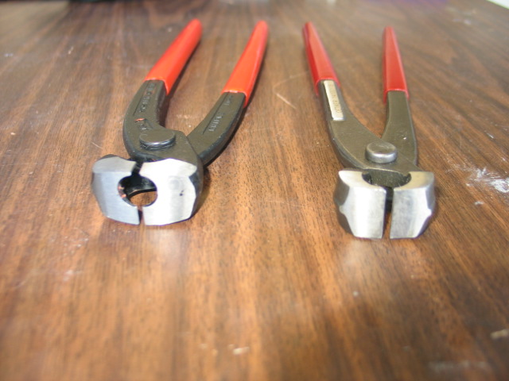
Now we should also mention that all your fuel and oil lines should be in fire sleeve. The best and industry standard is to use Band-It style clamps to secure the fire sleeve ends. These look like a little noose that gets pulled and cinched down to secure the fire sleeve. These can apply tremendous torque so only barely snug these down on any hose. If you over tighten these they will close off the hose underneath and restrict its flow. These clamps are already on the fire sleeve on the fuel pump from Rotax. The best way to remove these clamps and Oetiker clamps is with a Dremel tool and a re-enforced cut off wheel. You can use the Oetiker pinch pliers to remove these too.

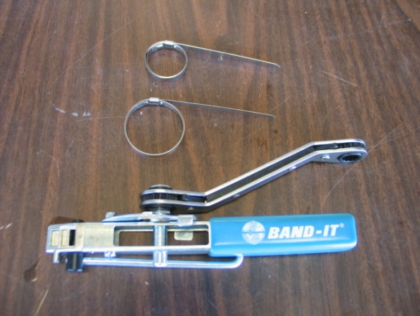
There is one last item to cover. We are supposed to seal the ends of the fire sleeve with something to keep fuel, oil or any liquid from wicking up into the fibers of the fire sleeve at its ends. You can use a couple of different methods. Some use the red silicone RTV and thin it slightly with a little toluene and brush it into the end and fibers of the fire sleeve. Some use a product called “End Dip” which comes in a quart can for $185-$225. You dip the fire sleeve ends and let it dry. I hate to sit and wait so there is one more good option. You can use fire sleeve self vulcanizing tape that is fire rated like the fire sleeve.

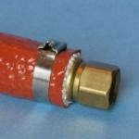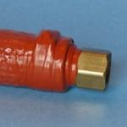
You as an owner can do one last safety check. After the hose has been installed and the engine is run and the carburetors synced you can run the engine for another 20-30 minutes on the ground at 3500-4000 rpm. Then head back to the hangar and pull the carburetor bowls off and look for any debris that may have escaped your careful planning and installation. It’s just a good safety check before your first flight and should help you cover all your bases in looking for any leaks and debris before your first flight.
So here we are at the end. The whole idea of this two part article is to make you think about keeping yourself and your passenger safe with a good solid maintenance practice and not being the test subject for hose time limits. Don’t worry there will still be the ones who, ”Won’t fix it until it breaks” that we can read about in the news with the off field landing or expensive engine tear down from a damaged engine. Hopefully you will look at a Rotax 5 year rubber change with a positive attitude and plan to think about what hose, tools and clamps you want to use and not use.

Everyone Fly Safe and Often!

