Fly In to Jet Age Museum, Gloucester, Sat 23 July.

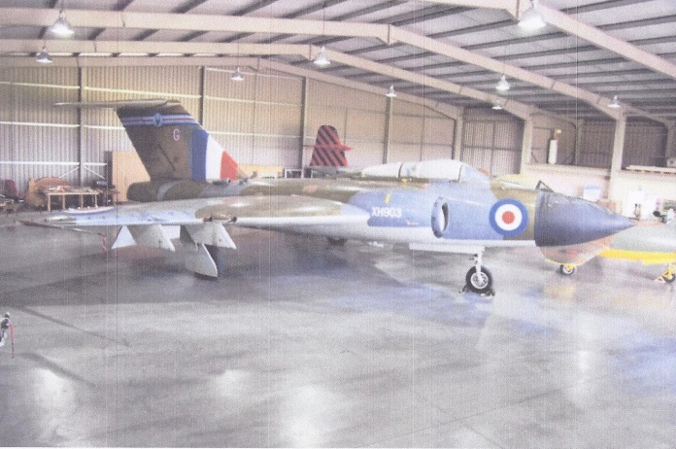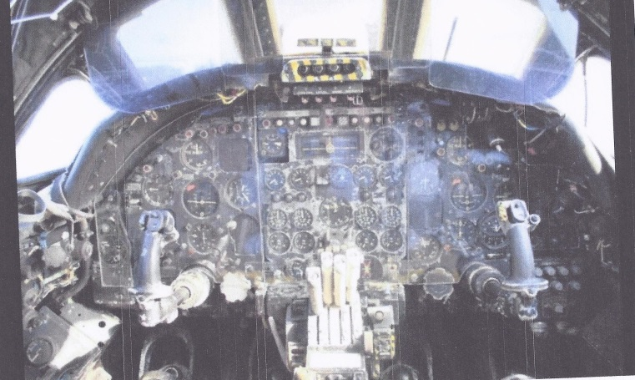

The Europa Club and Gloster Strut invite you to their Fly In and BBQ at the Jet Age Museum, Gloucestershire Airport, EGBJ. Last year’s event proved very popular and we have again planned a lavish 3 course menu (cost £5.00) and fully expect this again to be the best Fly In BBQ of the year! Free entry to the new Jet Age Museum – Sit at the controls of a Vulcan!
Reduced landing fee of just £5 for those registering their intention to come, and free if you uplift fuel. Arrivals from 11.30am. Mention JAM to ATC and they will direct you there.
To help catering we ask you to register your intention to come + number of pax + aircraft reg to davidjoyce@doctors.org.uk by midday Thursday 16/7. Those registering will be sent an acknowledgement with a briefing sheet. Those not registering but turning up on the day cannot be guaranteed food and will pay normal landing fees of £12+
Come and see what has made Gloucester the ‘Best GA Airfield’ in the UK for th 2 years running!



