Lightspeed 30-3g Headset Upgrade from Phone Plug to 6-Contact Lemo/Redel Plug and installation of mating Jacks in Experimental A/C wired to Panel Power. G. VanRemortel N1GV 03/25/19. THIS ARTICLE IS PROVIDED FREE OF CHARGE, IS NOT TO BE SOLD UNDER ANY CIRCUMSTANCES AND IS FOR EDUCATIONAL PURPOSES ONLY.

Bill of Material: (Qty) Desc, MFR and P/N, Price
(1) 6-Pin Plug, Redel PAG.M0.6NL.AC52NZ, $22
(1) Bend Relief, Redel GMA.1B.040.DN, $5
(2) 6-Socket Receptacle/Jack, Redel PTG.M0.6NL.LC52N, $30
(1) 6-Circuit Extension Cable, Pilot Communications PA-77B, $90
(2) Strain Relief, Tactical Eng FE-502-18A, $0.40ea
(2) 5-Circuit PicoBlade Housing, Molex 51021-0500 or TE 440146-5, $0.20ea
(>20) PicoBlade Socket, Molex 50079-8025 or TE 440147-2, $0.12ea
(2) DC-DC Converter, Drok 180040 (0.75”Wx1.75”Lx.40”T), $8ea (adjust/seal pot for 3VDC output before assy)
Various wire and shrink sleeving

Tools: Hakko Soldering Station or equivalent w/sharpest available tip, soldering related tools/supplies, softwood block and two thumbtacks (to stabilize PicoBlade sockets supplied on bandolier during termination)

Overview/Scope:
This upgrade retrofits two Lightspeed 30-3g (or similar) noise cancelling headsets with new I/O cables having 6-contact Redel plugs (pioneered by Bose). We will cannibalize PA-77B Extension Cable for one set of prewired Redel Plug and Receptacle and use remaining cable length for the second set we build with individual connectors. Pilot Communications wires their cables as 1=BLU, 2=BLK, 3=GRN, 4=YEL, 5=RED and 6=WHT, unless they have changed their spec. Please confirm the assumption before continuing.

Redel jacks are added to the A/C but phone jacks retained for use with older style headsets. Redel jack combines mic, stereo audio and panel power into a single high reliability latching connection same as that provided in many newer high-end Certified A/C. Panel power to the jack is sourced from any 3A fused circuit on the Avionics bus (anything from 10 to 32VDC will work).

Total cost of material is ~$200 and labor is about 1hr for each headset and 2hr for A/C. Headset may be restored to original configuration in ~30min, as long parts removed were saved. Because connectors and wiring used are so small, bench work under magnification is required. You will be soldering twenty 26AWG wires into socket contacts. Unless you intend to buy a multi-hundred-dollar crimping tool, precision soldering is required to accomplish the upgrade. Prewired Redel jacks 11-01846 can be bought from A/C Spruce for $55, if you prefer, but you’ll need two. To aid integration into my A/C, I added a 6-contact Molex .062” style connector pair so that all precision soldering could be done on bench, with only routine larger contact crimping done at the A/C. When PTT is already incorporated in A/C joystick(s) connection shown in wiring diagram is omitted.

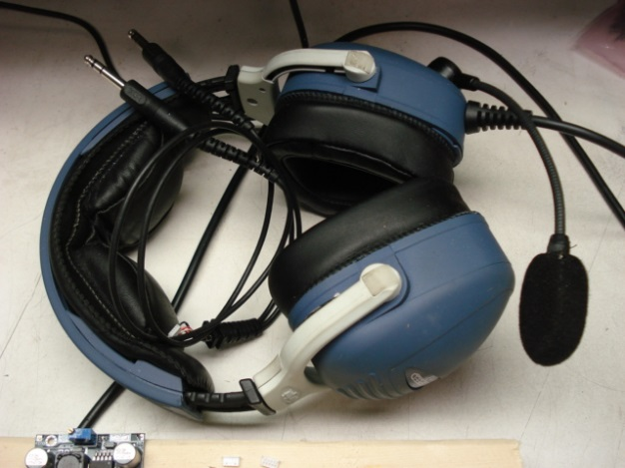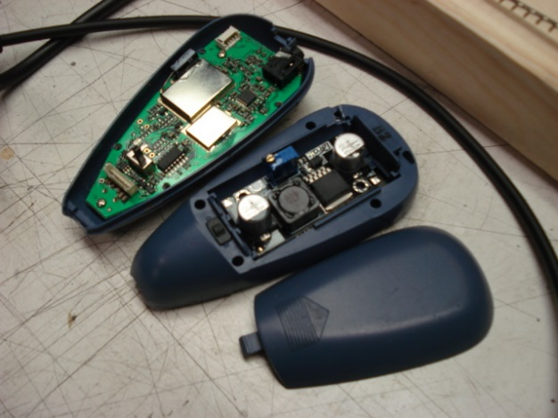

30-3g headset for upgrade (Photo 1) DC-DC converter in battery compartment (Photo 2)
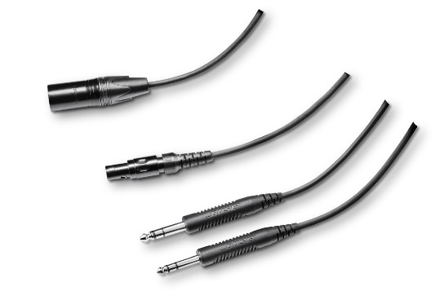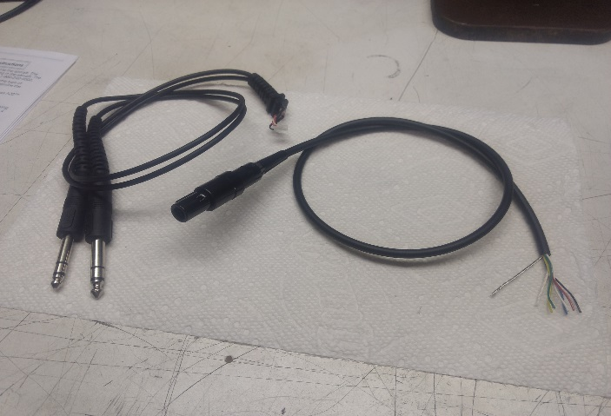
Old and new style plug cables (Photos 3 and 4)

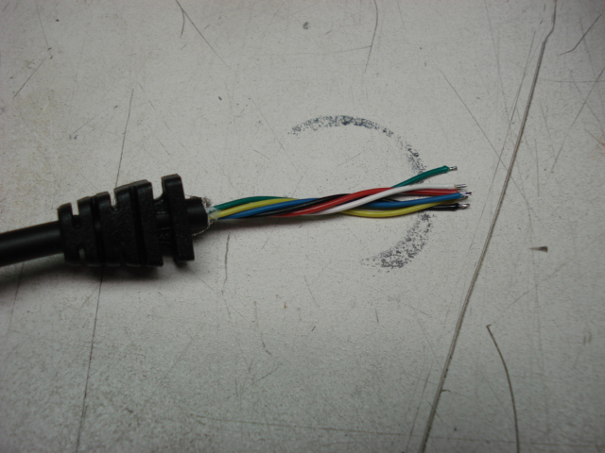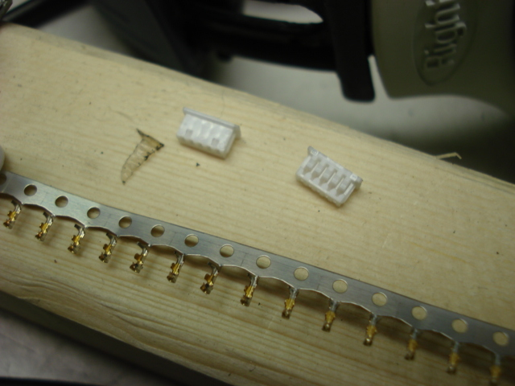
New cable with strain relief (Photo 5) PicoBlade housings and contacts (Photo 6)

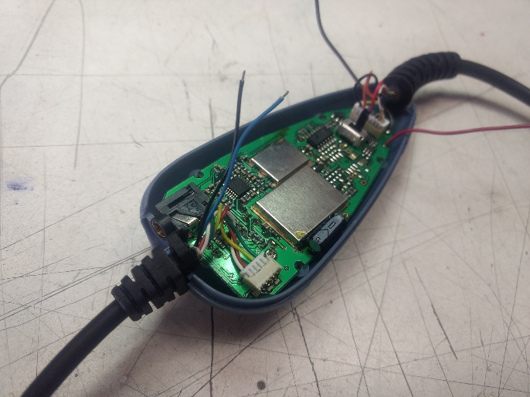
Pendant ready to close (Photo 7)

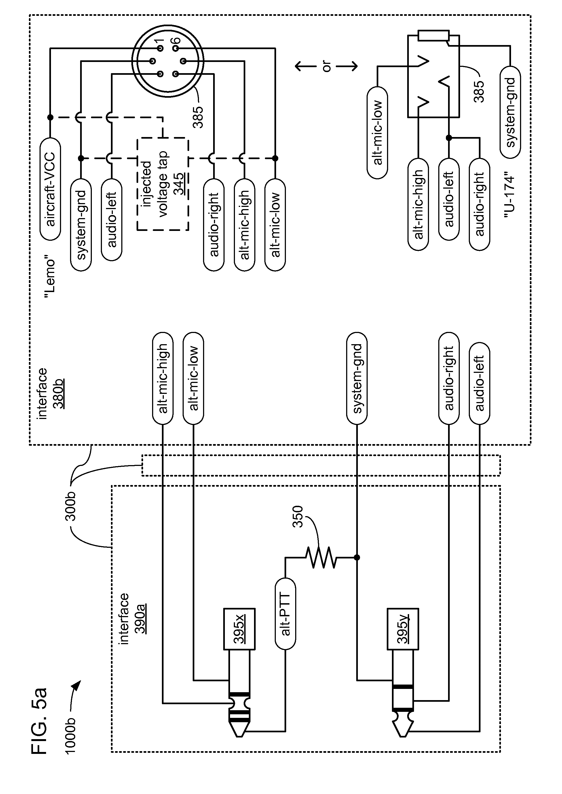
Lemo/Redel Jack (stereo) wiring diagram (ignore mono U-174 helicopter jack and reference numbers)

Headset Upgrade Suggested Sequence:

- Remove batteries from headset pendants
- Removing self-tapping screws and split pendant shells
- Carefully unplug and remove Y-cables
- Note that Pin1 (Left Audio Channel) end of PicoBlade points toward center of PCB
- Unsolder battery wires from PCB and solder 3” RED and BLK 24AWG wires in their place
- DO NOT remove PCBs from pendant shells as volume control detent balls can fall out and get lost
- Bend wired tabs of battery contacts up and remove all three contacts from compartments
- Cut PA-77B Redel plug end off with 20” of cable attached (ref Photo 4)
- Slide strain relief over cut end (ref Photo 5)
- Remove 2” of sheath from cut cable end (ref Photo 5)
- Trim shield flush with sheath and cut off guide string (ref Photo 5)
- Strip ~1mm of insulation from wires and tin (ref Photo 5)
- Carefully close crimp tabs and solder YEL, GRN, RED and WHT wires to PicoBlade sockets (ref Photo 6)
- Insert socketed wires into PicoBlade housing with barbs engaging housing tabs: Pin1=GRN, Pin2=YEL, Pin3=not needed, Pin4=RED and Pin5=WHT (ref Photo 6)
- Adjust strain relief on cable with ~.080” of sheath exposed and melt together using hot soldering tip
- Open up Redel plug by unscrewing backshell so that wiring is visible
- Solder a short length of BLK 26AWG wire between cable shield and side of Pin2
- With this cable apart for reference, make cable for second headset using 20” of remaining cable, Redel plug, Bend Relief, Strain Relief, PicoBlade contacts and housing, repeating Steps 9-17.
- Close up Redel plug
- Install new cable in pendant while poking in and out power wires through access holes (ref Photo 7)
- Ensure stereo/mono cap engages switch handle on PCB.
- Screw together pendant shells using self-tapping screws removed in Step 2
- Place DC-DC converter in battery compartment orienting as shown (ref Photo 2)
- Solder wires: +IN=BLU, -IN=BLK, +OUT=RED and -OUT=BLK
- Install battery compartment lid using a weak adhesive like RTV
- Use the remaining materials for installing jacks in A/C and enjoy

