Wiring of the S704 in Z101
The Z101 diagram has the following detail in the upper left – I have added letters A-E to name the fast-on terminals.
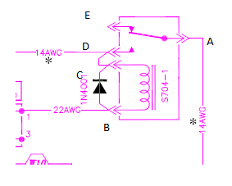
B&C publishes directions for installing the S704-1, as follows:
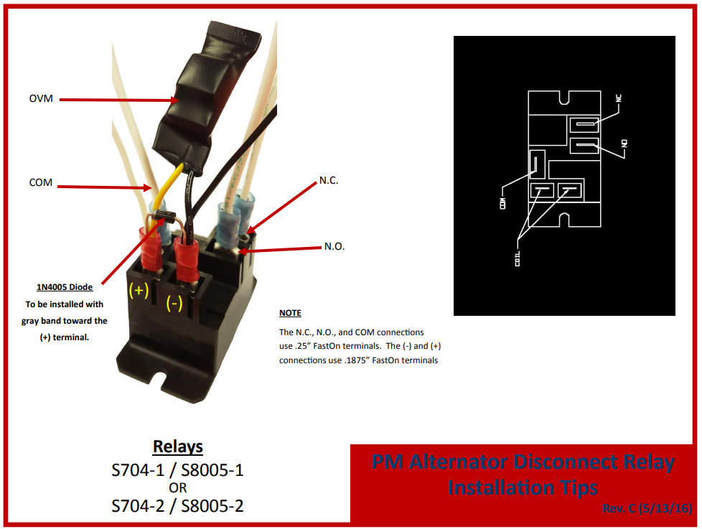
Here is how I read the cross-mapping:
A = Com in this case a feed over to the engine bus
B = the coil negative
C = the coil positive
D = NO, the normally open terminal, in this case connected from the fat wire tie point
E = NC, the normally closed terminal. Here, unused, as there is no flow of current until the coil fires and we get the alternate power feed through D to A and into the engine bus.
B&C are connected by a diode and C&D are jumpered

