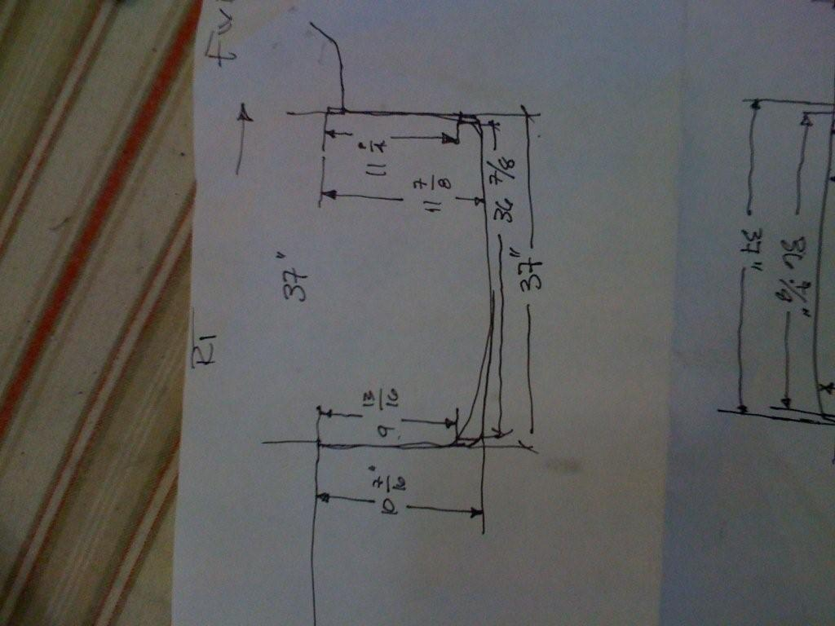
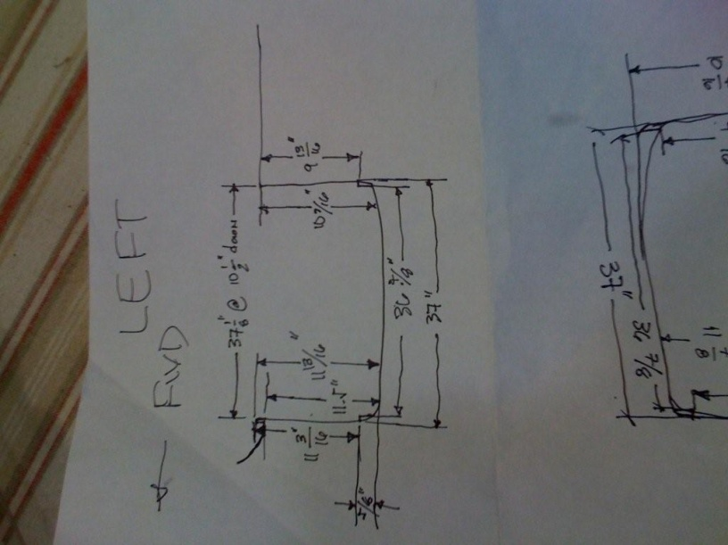
This picture is of the door opening measurements that were taken at an Air Crafters fibreglass course. When trimming the door opening on the canopy, you will find that you have to trim much more than suggested by the Van's plans. Just measure the door opening width and then compare to the fibreglass that has to fit into that opening and you will see what I mean.

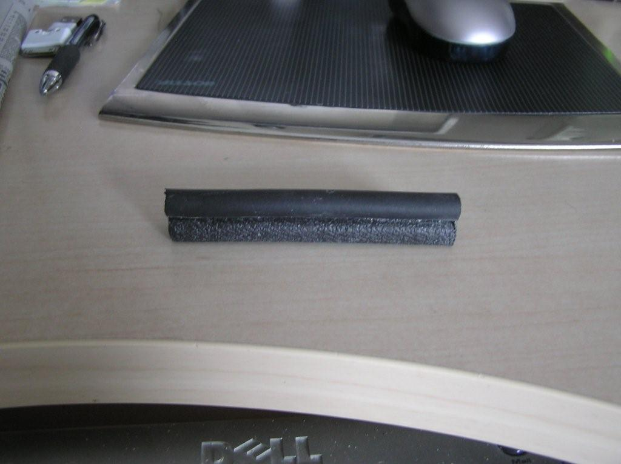
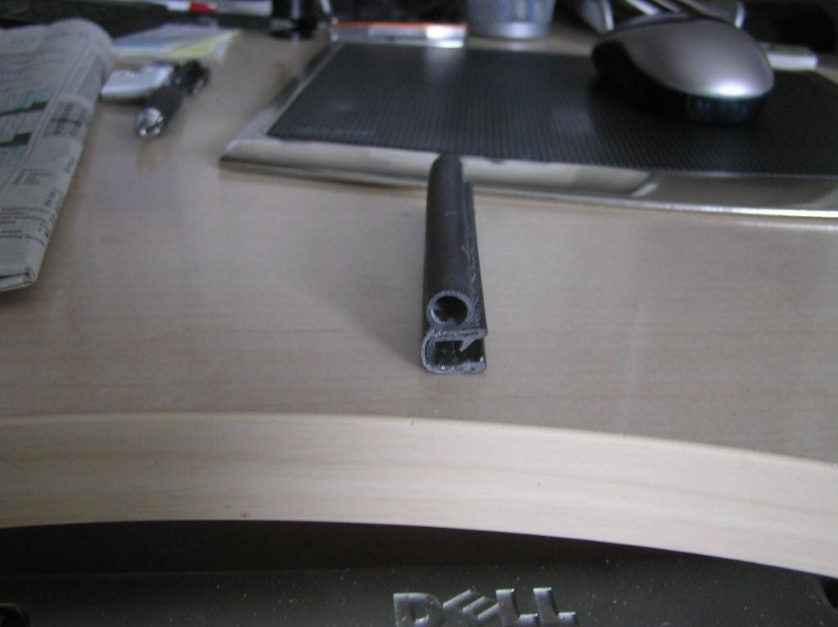
This is a picture of a short length of the McMaster Carr seals as well as an end on shot.

Once I had the canopy fully on the fuse, I aligned the door frame in the fuselage opening and drilled #30 holes around the opening perimeter. I Did NOT drill the holes to #12 and # 19 as per the plans, this I left until later. You can just see the end of the cleco’s that protrude through the fibreglass from the back side. This was sufficient to hold everything in place until the doors and door hardware were installed.
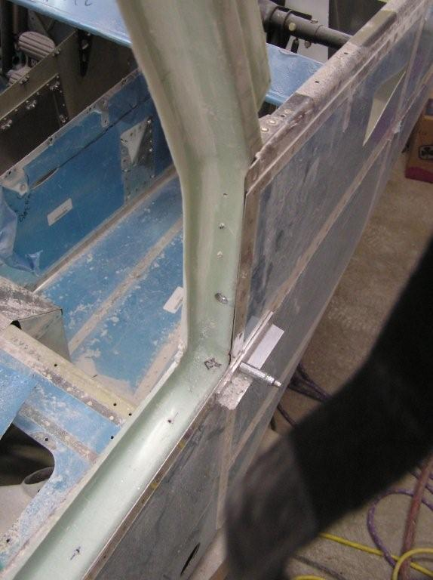

I should have mentioned that on the previous photo, it shows how all of the outward opening radii around the door opening have been cut away. This allows the seals to sit square to the door with the compression bulb facing outward.
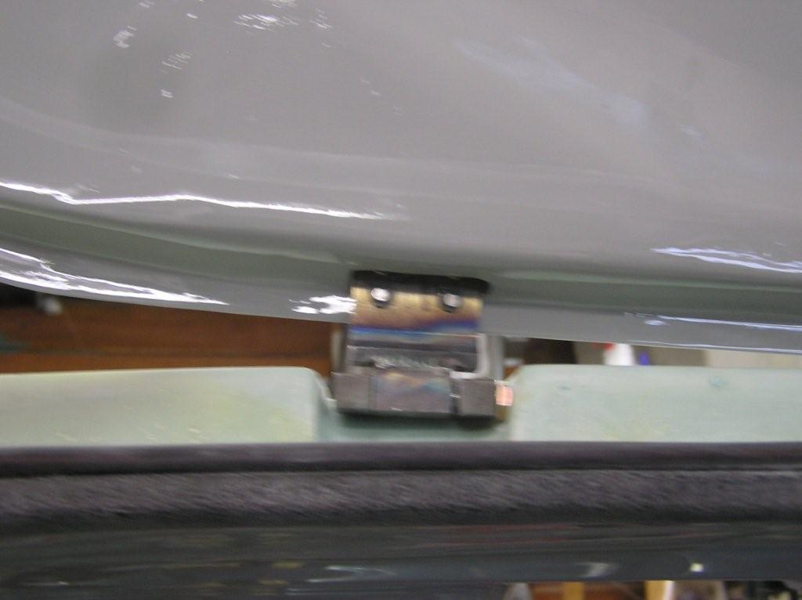
I had to move the bottom portion of the port door sill inboard about 1/8" to reduce the pressure on the door when closing. This is one of the advantages of not doing final installation of the canopy until the door fit is confirmed, as it enables you to still move things around in the opening as required and then permanently install the canopy when you are happy with the door fit.
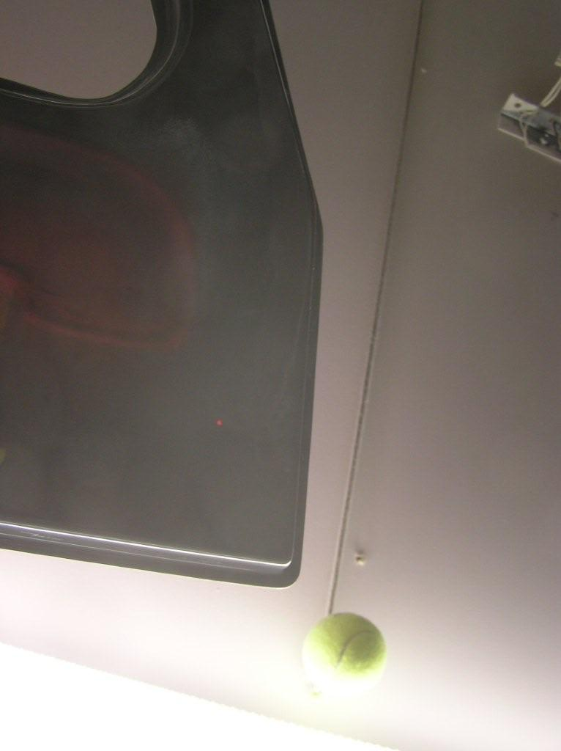
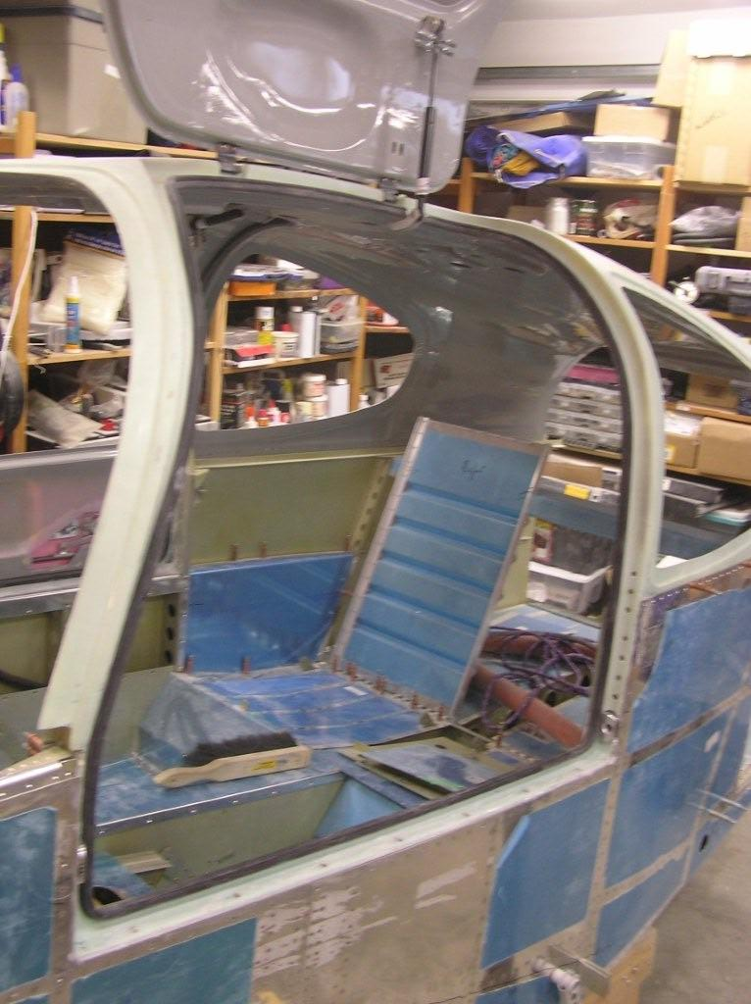

Hopefully you have seen all my other emails. The McMaster Carr seals cost about US$1.00 per lineal foot. And they fit onto the door opening with a pressure fit (they slide on); you don't have to worry about using adhesive. You will have to put a bead of Proseal or silicone sealant into the notch just to keep everything watertight but this is no big issue.
I glassed in the door hinges leaving only a small slot for the door side of the hinges to go in. As the back side of the hinge was now blind, I installed nutplates on the back of the hinges.
I also glassed in the nylon door guides that fit on the forward and aft ends of the door. The pictures aren't great but you should see what I mean. I have also included a picture of the door opening with the seals on, which also shows how I got a nice smooth channel for the seals.
With the seals in place, I put Superfil along the back side of the seal. When hardened, I pulled the seals off and had a nice smooth channel on the interior side for the seals to sit in. I hope this is clear.
Here are three pictures that show how I notched my lower door sill for the door seals. Firstly I temporarily installed the seals and then filled the gap below the seals with Superfil. Initially, it doesn't look pretty. Then I sanded the Superfil so it was much neater.
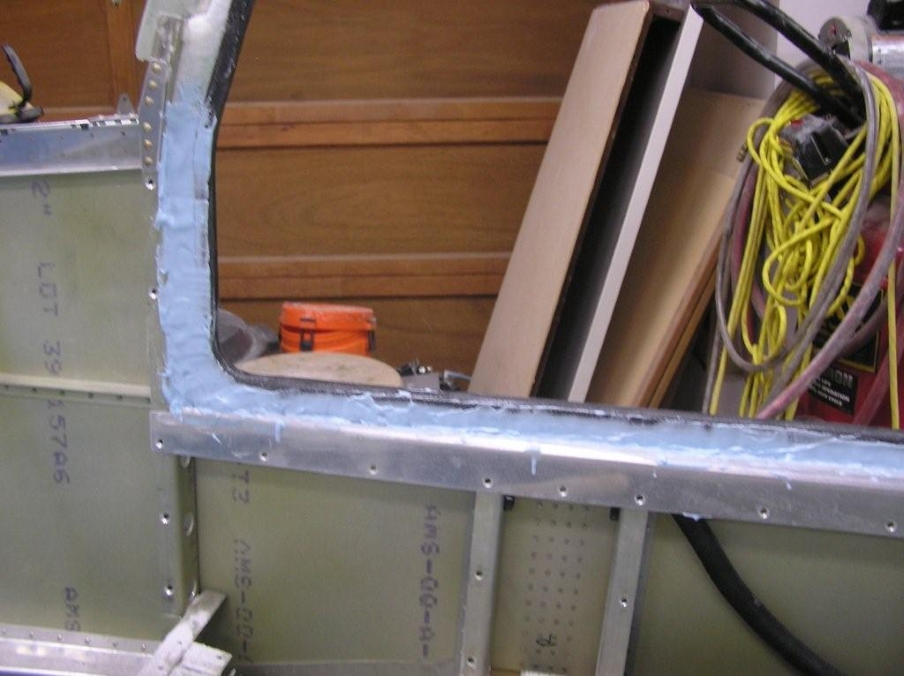

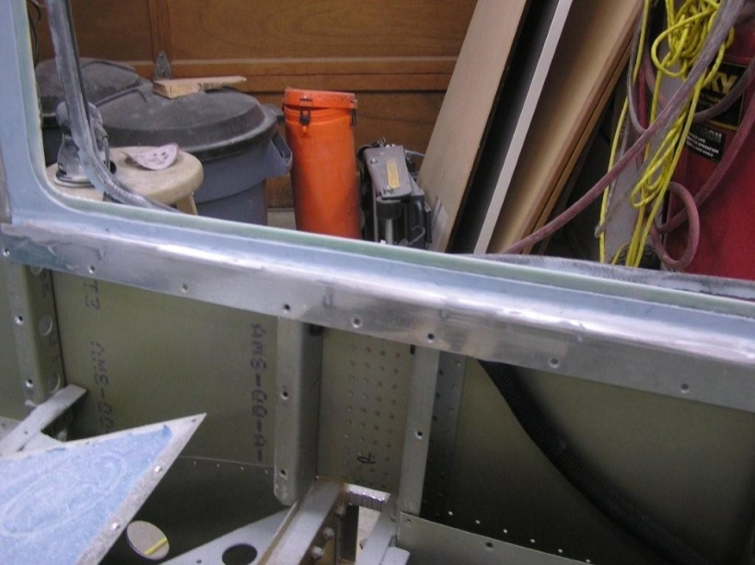
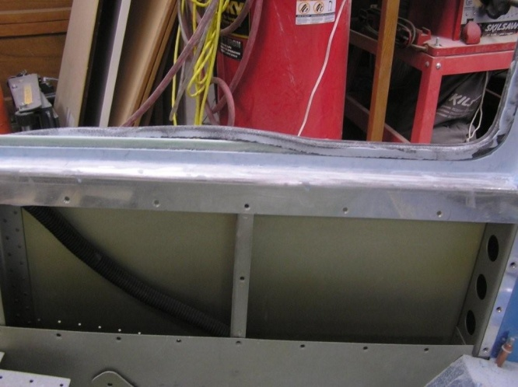
The second photo shows the result after sanding (following removal of the seal).

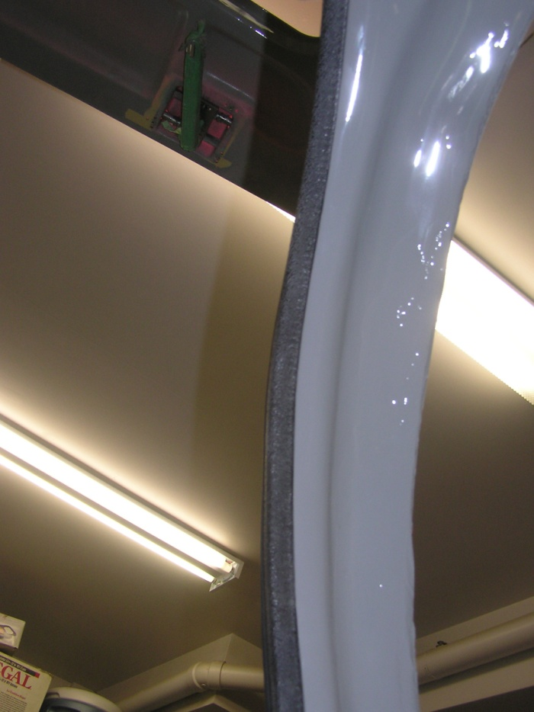
The last photo shows the seal partially removed. The result is a nice neat finished look when viewed from the cabin side, especially when painted.
The last photo is of the upper canopy door opening (forward pillar) with the door seal installed. Although you can't see it very well, there is a smooth transition for the seal to the canopy. Note, in this pix, the canopy interior has been painted.
Anyway, the key to good seals is to have continuous contact all the way around the door. By glassing in the door blocks and the opening for the
hinges, the only break is for the fitting for the door lift on the top of the door. Even here, it will be possible to fit the seals (with a fit of effort).

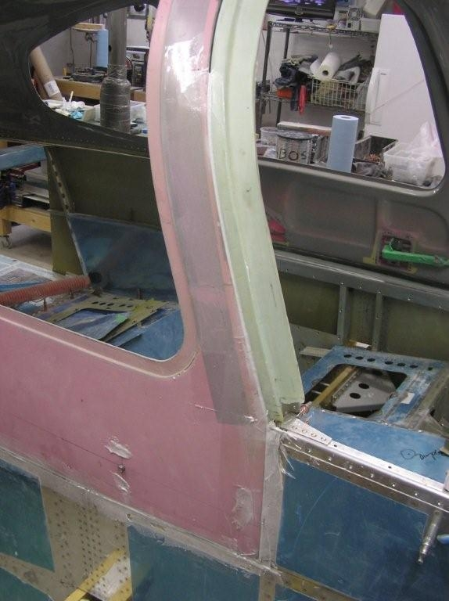
These photos show hope I filled the gaps between the door and the canopy. In the first, you can see the packing tape wrapped around the door perimeter. You can also see where I forced an epoxy / flox mixture between the canopy and door. This effectively sealed the gap. I did this a section at a time over a couple of days so as not to make the door too difficult to open. Although the epoxy doesn't adhere to the packing tape very well, it does take a bit of effort to separate.
The second photo shows the end result. The epoxy appears as "white icing" around the perimeter. I will fill behind the white epoxy with Superfil and sand flush once I have adjusted for the final door gap.
Note - this does not deal with the uneven level between the door and the
canopy - it only resolves gaps.

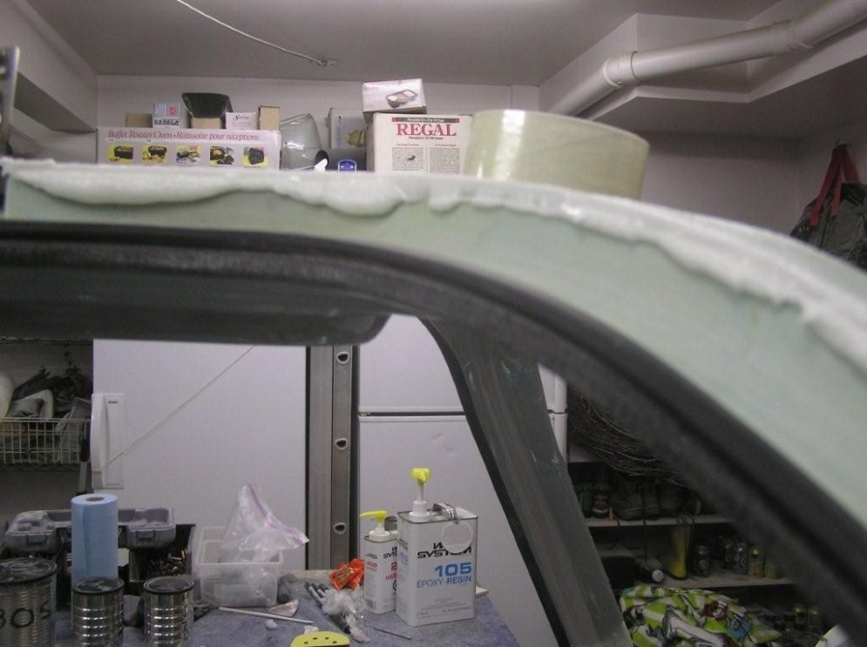

This shows how I got the door and canopy on the same "plane". I closed the door and then spread an epoxy / micro balloon mixture across the transition from the door to the canopy. Low areas on either the door or canopy were filled.
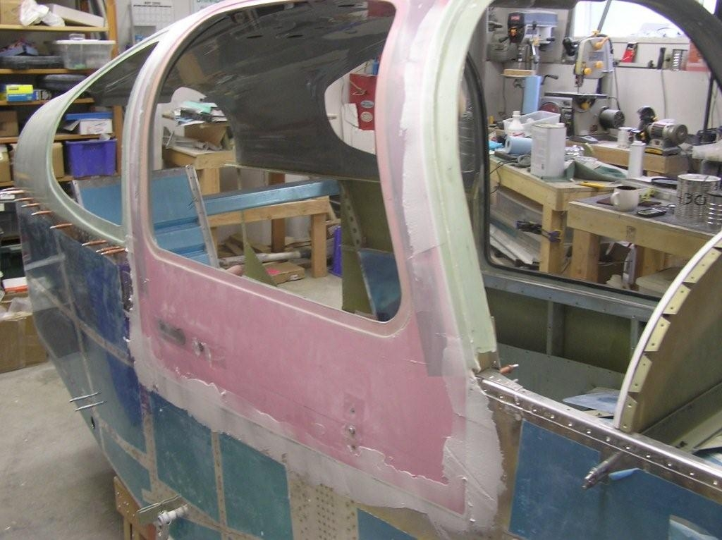
Once the entire perimeter was ‘flushed’ as shown above, I opened the door and allowed both sides to cure. After curing I sanded the edges so the doors would close (this process left ragged edges that interfered with door closing - photos 2 # 3).
The photo to the right shows the result after filling. You can clearly see how the door gap has been filled and is now even throughout.
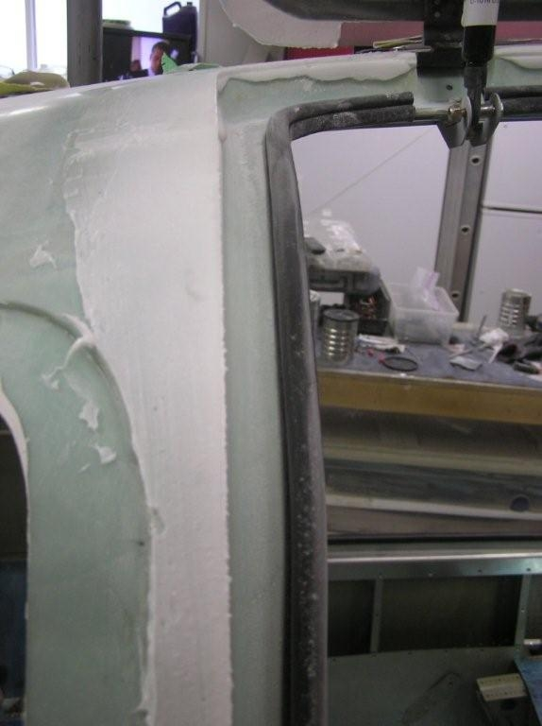
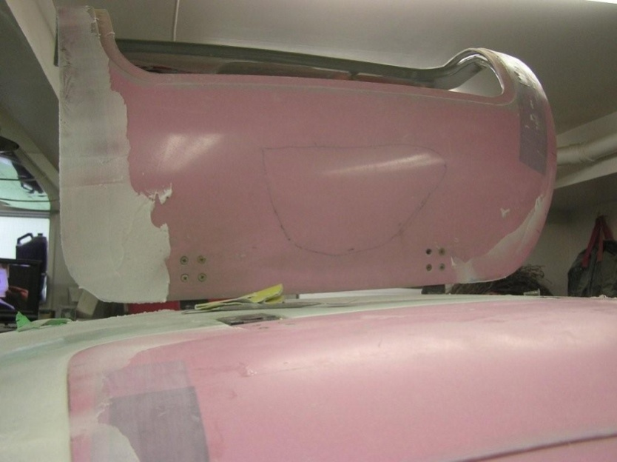
These last two photos show the door gap after filling and sanding. Some minor feathering is required, but things are close to being finished. The mottled look is pretty ugly, but this will be covered by paint so it doesn't matter. What appears as bumps on the door is tape protecting the door hardware.
After all is said and done, I have got my doors to close with the pressure of one finger. On their own, the doors will close to within ½” to ¾”. This is something I wouldn't have believed possible when I started fitting the doors. At one point I was wondering if I was going to have to order a new door - I was that discouraged.
Finally, I bought 100 feet of seals so I have enough to do six doors. While fitting the doors, I used two lengths that will be scrapped when all is said and done. Then I will have enough to do the doors and have a spare set.
Although I am in Canada, I can call Australia for free (the internet is a wonderful thing) so if you would like to chat, just shoot me an email with your number, we’ll manage the time difference, so just let me know what time works for you keeping in mind the time difference here.
PS: Much, if not all of the ideas in my emails I have shamelessly stolen from
other builders who were kind enough to help me out.
The McMaster Carr part number for the seal material is #1120A313, and can be found via the online McMaster Carr catalogue at http://www.mcmaster.com/#edge-seals/=4175l2.
I gave them a call and they will sell into Australia so it would be simpler if you cut out the middle man (me). You can order online so it should be very simple for you. Get a 100’ and you will have lots. When I bought mine, they didn’t sell into Canada so I have a friend in the US ship them to me. Fortunately, they will sell to Canada now.

Cheers

Les Kearney
Alberta, Canada

