Air Scout Camp, Defford, Sat 8th September 2018, (weather
alternate 9 September)

We are looking for volunteer pilots to help with flying boy and girl scouts at their annual camp at Croft Farm, Defford (and we would particularly welcome more lady pilots to help with this highly successful event).

Defford details are in Pooleys but it is essentially a 570 metre E-W grass strip with good approaches and smooth surface, about 10 miles North of Gloucester. We generally have about 30 to 40 scouts to fly (and getting on for half of these are girls) and our pilots will mostly do 3 or 4 flights round a pleasant 27 mile course circumnavigating the Malvern hills and taking perhaps 20 mins. All of us who have been involved in the past have found this to be a highly rewarding experience, sharing in the enormous enthusiasm of the children. A surprisingly good lunch is provided by the scouts including absolutely cracking pancakes!

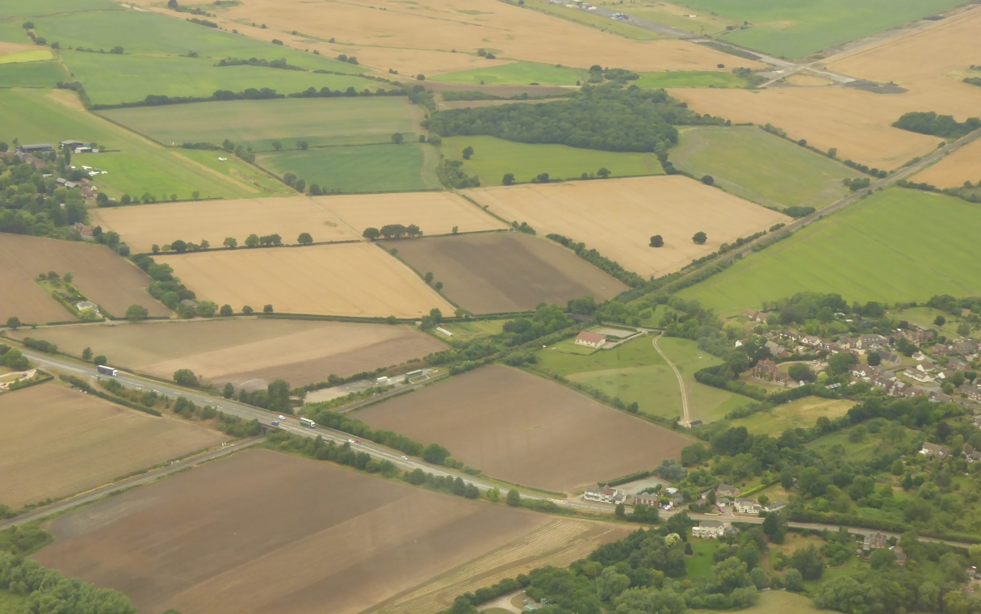
Croft Farm Strip top left.
Defford Village right

Pilot requirements ask for >250 hrs total with 150hrs PIC, 20 hrs PIC on type, 10hrs or 15 landings in last 3 months and 3 landings in last one month. There are no age restrictions.

If you feel you might be able to help please contact me, and I will send or give you at Strut meeting full briefing details. David Joyce: davidjoyce@doctors.org.uk Tel 01454 260542

